1. Waste report:

Job # (job.job-no, job.job-no2)

Job close day (job.close-date)

Customer (job-hdr.cust-no)

Qty produced at each machine for that job (mch-act.qty) JQ1 MachQty Tab

Waste reported (mch-act.waste)

Table Joins:

Job table

job.company = company code (for example 001)

job.job-no = job-number

job.job-no2 = job-sub number

Job-Hdr table (record for each sheet and blank and the job)

job-hdr.company = = company code (for example 001)

job-hdr.job-no = job.job-no

job-hdr.job-no2 = job.job-no2

Mch-Act table (each machine on the job has its own record)

mch-act.company = = company code (for example 001)

mch-act.job = job.job

1. Closed jobs analysis:

Job# (job-hdr.job-no and job-hdr.job-no2)

Job Qty (job-hdr.qty)

Customer (job-hdr.cust-no)

Qty Produced at each machine for that job (mch-act.qty)

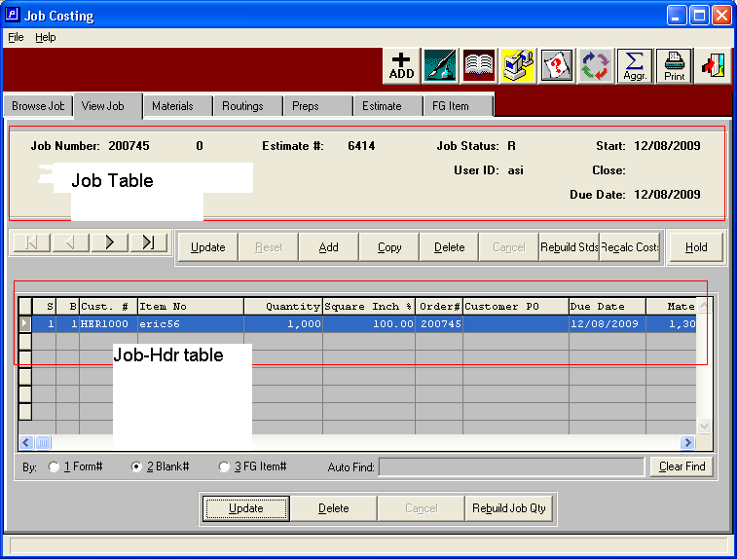

JR5

Here is some code that shows how the quantity produced field is calculated:

Work-item.qty-prod is a temporary field used in report used to keep track of the quantity produced.

Itemfg.company = company code

Itemfg.i-no = job-hdr.i-no

IF itemfg.isaset AND itemfg.alloc THEN

FOR EACH fg-act

WHERE fg-act.company eq job-hdr.company

AND fg-act.job-no eq job-hdr.job-no

AND fg-act.job-no2 eq job-hdr.job-no2

AND fg-act.i-no eq job-hdr.i-no:

work-item.qty-prod = work-item.qty-prod + fg-act.qty.

END.

/\*Posted finished good receipts\*/

FOR EACH fg-rcpth

WHERE fg-rcpth.company EQ job-hdr.company

AND fg-rcpth.i-no EQ job-hdr.i-no

AND fg-rcpth.job-no EQ job-hdr.job-no

AND fg-rcpth.job-no2 EQ job-hdr.job-no2

AND fg-rcpth.rita-code EQ "R",

EACH fg-rdtlh NO-LOCK

WHERE fg-rdtlh.r-no EQ fg-rcpth.r-no

AND fg-rdtlh.rita-code EQ fg-rcpth.rita-code:

work-item.qty-prod = work-item.qty-prod + fg-rdtlh.qty.

END.

Selling Price –  Sum of oe-ordl.t-price for that item

oe-ordl.t-price

Oe-ordl.company = company-code

Oe-ordl.job-no = job-hdr.job-no

Oe-ordl.job-no2 = job-hdr.job-no2

Oe-ordl.ord-no = job-hdr.ord-no

Oe-ordl.i-no = job-hdr.i-no

Quantity Ordered –  Some of oe-ordlqty for that item

oe-ordl.qty

Oe-ordl.company = company-code

Oe-ordl.job-no = job-hdr.job-no

Oe-ordl.job-no2 = job-hdr.job-no2

Oe-ordl.ord-no = job-hdr.ord-no

Oe-ordl.i-no = job-hdr.i-no